**Built in Http MiddleWares:**

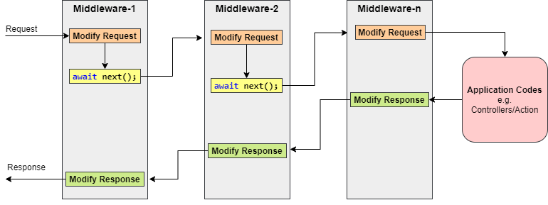

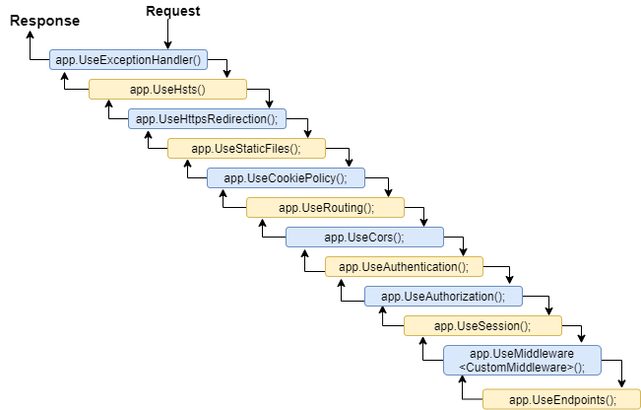

**UseExceptionHandler:**

UseExceptionHandler(IApplicationBuilder, ExceptionHandlerOptions) Adds a middleware to the pipeline that will catch exceptions, log them, and re-execute the request in an alternate pipeline. The request will not be re-executed if the response has already started.

**UseHsts:**

UseHsts adds a **header Strict-Transport-Security** to the response. When the site was accessed using HTTPS then the browser notes it down and future request using HTTP will be redirected to HTTPS. So, accessing the site using HTTPS at least once is mandatory to make this work.

**UseHttpsRedirection:**

The HTTPS Redirection Middleware to redirect all HTTP requests to HTTPS.

**UseStaticFiles:**

The ability to serve the static files directly from the wwwroot folder. The static files such as HTML, Images, CSS, and JavaScript are the important assets of an application and ASP.NET Core can serve these files directly to the clients. But the important point that you need to keep in mind by default the ASP.NET Core cannot serve these static files. Some configuration is required in order to enable the ASP.NET Core to serve these static files directly.

**UseAuthentication/UseAuthorization**

Authorization defines what a given user can do within the app. It's separate from authentication, which is concerned merely with identifying who the user is.

**UseCors:**

Cross-Origin Resource Sharing or CORS

builder.Services.AddCors(options =>

{

options.AddPolicy(name: MyAllowSpecificOrigins,

builder =>

{

builder.WithOrigins("http://example.com",

"http://www.contoso.com");

});

});

app.UseCors(MyAllowSpecificOrigins);